**Project Design Phase-II**

**Technology Stack (Architecture & Stack)**

|  |  |
| --- | --- |
| Team ID | PNT2022TMID10342 |
| Project Name | University Admit Eligibility Predictor |
| Maximum Marks | 4 Marks |

**Technical Architecture:**

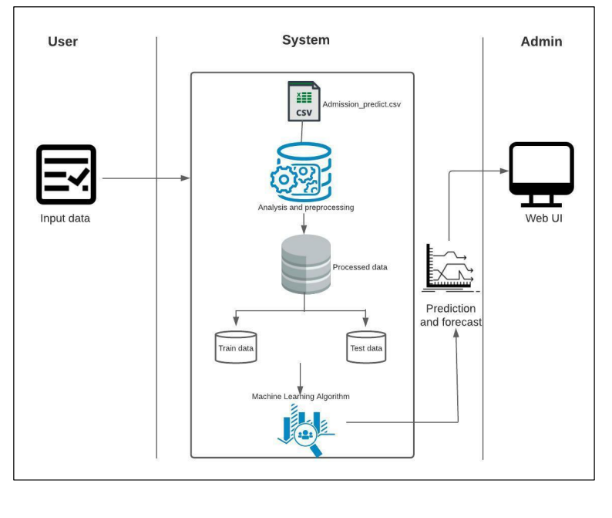

**Table-1 : Components & Technologies:**

|  |  |  |  |
| --- | --- | --- | --- |
| **S. No** | **Component** | **Description** | **Technology** |
|  | User Interface | How user interacts with application through the web UI | HTML, CSS, Flask, Python |
|  | Application Logic-1 | Logic for collecting the input from the user | Python |
|  | Application Logic-2 | Integrating Machine Learning model with our application | Python |
|  | Database | Numeric Data | MySQL, |
|  | Cloud Database | Database Service on Cloud | IBM Cloud. |
|  | File Storage | To store files such as prediction report | Local file system |
|  | Machine Learning Model | Predictive Modelling is a mathematical process used to predict future events or the outcomes by analysing patterns in a given set of input data. | Predictive modelling |
|  | Infrastructure (Server) | Application Deployment on Local System  Local Server Configuration: Built-in Flask web server | Flask, Web Server |

**Table-2: Application Characteristics:**

| **S. No** | **Characteristics** | **Description** | **Technology** |
| --- | --- | --- | --- |
|  | Open-Source Frameworks | Flask | Micro web framework with python |
|  | Security Implementations | Http authentication, Session based authentication | Flask Security |
|  | Scalable Architecture | Size is everything, and flask’s status as a microframework means that you can use it to grow a tech project such as a web app incredibly quickly. Its simplicity of use and few dependencies enable it to run smoothly even as it scales up and up. | Flask |
|  | Availability | Higher compatibility with latest technologies and allows customization | Flask |
|  | Performance | Integration support for unit testing.   * Restful request for unit testing * Uses jinja templating * Support for secure cookies | Flask |